1. **Slip 12 A) Write a Python GUI program to create a label and change the label font style (font name, bold, size) using tkinter module.**

import tkinter as tk  
parent = tk.Tk()  
parent.title("Welcome to College Student");  
my_label = tk.Label(parent, text="Hello", font=("Arial Bold", 70))  
my_label.grid(column=0, row=0)  
parent.mainloop()

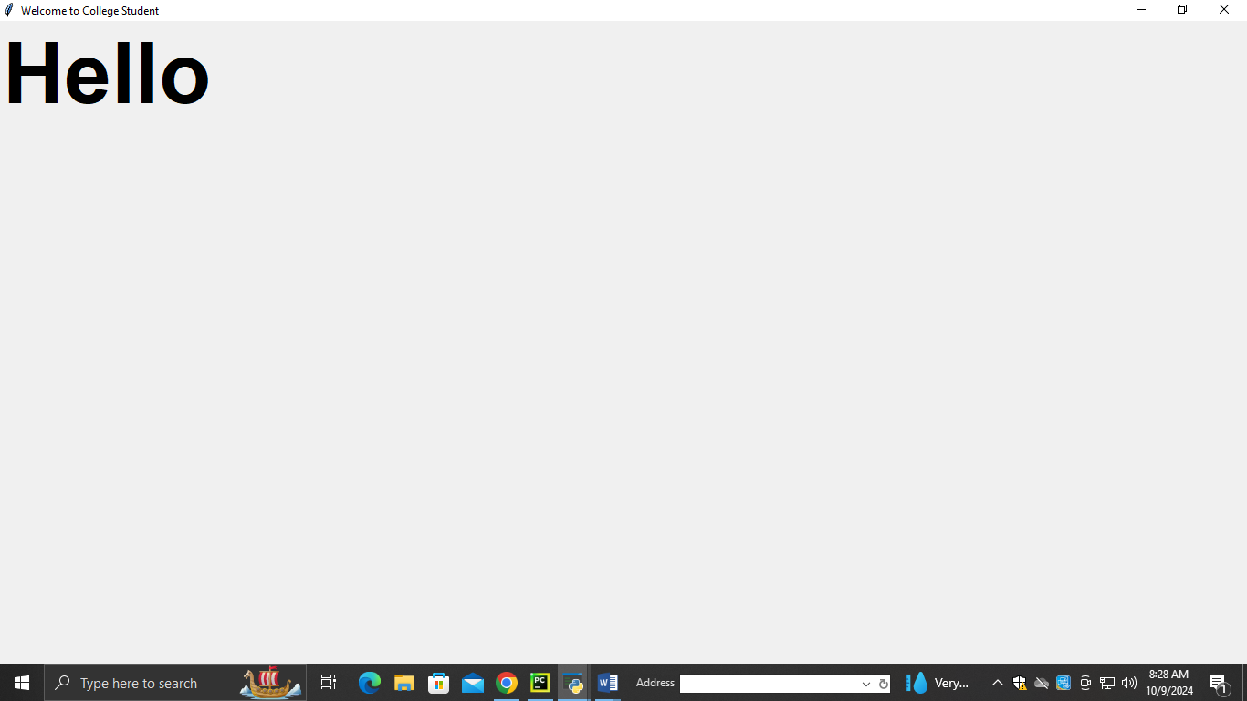

**2. Slip 2 B) Write Python GUI program to create a digital clock with Tkinter to display the time.**

from time import strftime  
root = Tk()  
root.title('Clock')  
def time():  
 string = strftime('%H:%M:%S %p')  
 lbl.config(text=string)  
 lbl.after(1000, time)  
lbl = Label(root, font=('calibri', 40, 'bold'), background='purple', foreground='white')  
lbl.pack(anchor='center')  
time()  
mainloop()

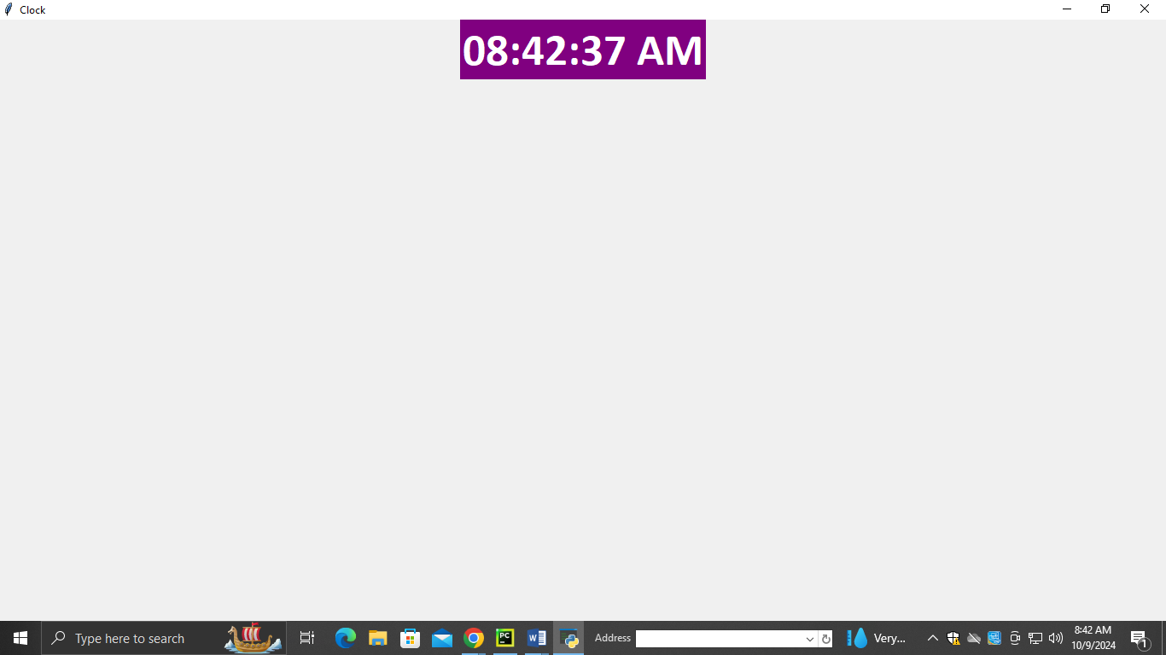

1. **Slip 11 B) Write Python GUI program to add menu bar with name of colors as options to change the background color as per selection from menu option.**

from tkinter import *  
app = Tk()  
  
app.title("Hi !Welcome to TYBBACA Students")  
app.geometry("800x500")  
  
menubar = Menu(app, background='blue', fg='white')  
  
file = Menu(menubar, tearoff=False, background='yellow')  
  
edit = Menu(menubar, tearoff=False, background='pink')  
file.add_command(label="New")  
file.add_command(label="Exit", command=app.quit)  
edit.add_command(label="Cut")  
edit.add_command(label="Copy")  
edit.add_command(label="Paste")  
menubar.add_cascade(label="File", menu=file)  
menubar.add_cascade(label="Edit", menu=edit)  
app.config(menu=menubar)  
app.mainloop()

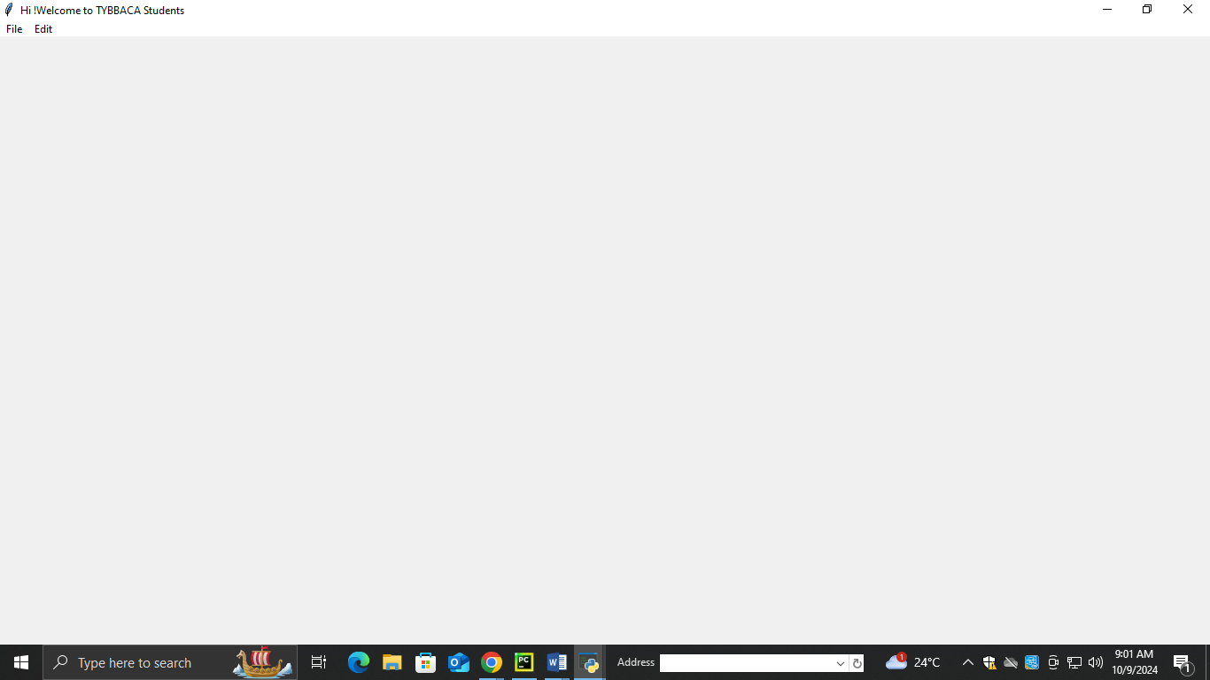

1. [**Slip 4  A) Write Python GUI program to create background with changing colors**](https://team-analytics.blogspot.com/2021/12/savitribai-phule-pune-university_62.html)

import tkinter as tk  
parent = tk.Tk()  
parent.title("Window with Background Color")  
parent.configure(bg="lightblue")  
parent.mainloop()

